Deploying a Node.js Web Application

On AWS Free Tier Using Docker & Kubernetes

Name | Sabeeh Aamir Paracha
Student ID
Subject | Cloud Computing
Submission Date | Saturday, May 30th, 2026
GitHub Repository Link | https://github.com/SabeehP09/Project-Sabeeh.git
Web App URL/IP Address | http://44.197.175.195:3000

Introduction
In modern software engineering, deploying applications reliably and at scale is a critical skill. This project addresses the challenge of taking a simple web application from source code to a publicly accessible, containerized service running on the cloud. The problem it solves is threefold: environment consistency (eliminating “it works on my machine”), scalability (managing application instances efficiently), and cost-effective cloud deployment (leveraging free-tier resources for learning).
Docker containers are important because they package the application with all its dependencies, ensuring identical behavior across development, staging, and production environments. Kubernetes automates deployment, scaling, and management of containerized applications. Even on a single-node Minikube cluster, it demonstrates core orchestration concepts such as deployments, services, and health probes, and AWS provides 12 months of free-tier access to EC2 (750 hours/month of t2.micro), 500 MB/month of ECR storage, and no charges for Minikube. This makes the project completely free while exposing students to industry-standard cloud infrastructure.

Architecture Diagram
The following architecture illustrates the complete data flow from the developer’s machine to the end user:
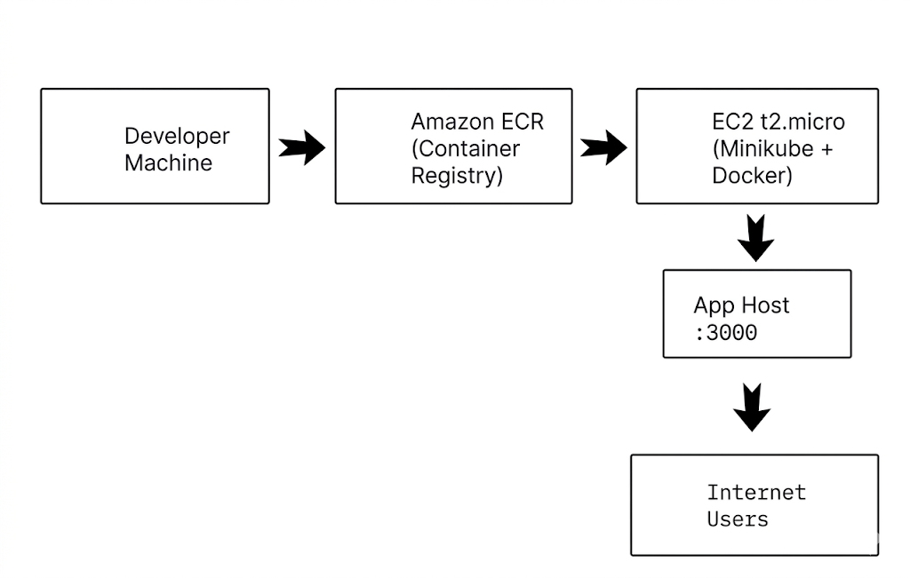
Figure 1. System architecture showing Docker image flow from local build to ECR, then deployment on Minikube via EC2, exposed via NodePort.

Step-by-Step Implementation

Phase 1: Node.js Web Application
A lightweight Express.js server was built (src/app.js). It serves an HTML dashboard displaying three dynamic metrics: a live ISO timestamp, the container hostname (shortened to 12 characters to mimic Docker container IDs), and a persistent visitor counter stored in counter.json. A /health endpoint returns JSON status for Kubernetes liveness and readiness probes.

Phase 2: Docker Containerization
A multi-stage Dockerfile was created using the node:18-alpine base image. The first stage installs production dependencies. The second stage copies only the necessary artifacts, creates a non-root nodejs user for security, exposes port 3000, and defines a HEALTHCHECK instruction. The final image size is approximately 180 MB.

Phase 3: Push Image to Amazon ECR
Using the AWS CLI, an ECR repository named nodejs-aws-k8s-app was created. The build-and-push.sh script automates Docker authentication (aws ecr get-login-password), image tagging with the ECR registry URI, and the push operation. ECR offers 500 MB of free storage monthly.

Phase 4: Launch EC2 Instance (Free Tier)
An EC2 t2.micro instance was launched using the Amazon Linux 2023 AMI. Configuration: 1 vCPU, 1 GB RAM, 20 GB gp2 storage, and a security group allowing inbound traffic on ports 22 (SSH), 80 (HTTP), and 3000 (NodePort). The instance public IPv4 address was recorded for browser access.

Phase 5: Install Docker & Minikube on EC2
The setup-ec2.sh script automated the installation of Docker CE, kubectl, Minikube, and AWS CLI v2. Minikube was started with the Docker driver (minikube start --driver=docker) to run a single-node Kubernetes cluster within the EC2 instance.

Phase 6: Authenticate EC2 to ECR
From the EC2 instance, the AWS CLI was configured with an IAM user possessing AmazonEC2ContainerRegistryReadOnly permissions. Docker login to ECR was performed so Minikube could pull the private image during deployment.

Phase 7: Deploy to Kubernetes (Minikube)
Two YAML manifests were applied:
- deployment.yaml: Defines a Deployment with 1 replica, resource requests/limits (64Mi–256Mi memory, 100m–250m CPU), liveness probe on /health, and the ECR image URI.
- service.yaml: Defines a NodePort Service mapping port 80 to container port 3000 on NodePort 3000.
The deploy-k8s.sh script replaces placeholder values in the manifest with the actual ECR URI before running kubectl apply.

Phase 8: Testing & Verification
Verification commands executed successfully:
- kubectl get pods — showed status Running
- kubectl get services — showed NodePort on port 3000
- Browser access to http://44.197.175.195:3000 displayed the live application
- kubectl scale deployment nodejs-app-deployment --replicas=2 — successfully scaled the app

Phase 9: Clean Up Resources
To maintain zero cost, all resources were terminated: Kubernetes manifests deleted, Minikube cluster stopped and removed, EC2 instance terminated, and ECR repository deleted. AWS Cost Explorer confirmed $0.00 charges.

Challenges Faced

Challenge 1: Permission Denied for Docker Commands on EC2
After installing Docker on EC2, running docker ps returned a “permission denied” error because the default user was not in the docker group.
Resolution: Executed sudo usermod -aG docker $USER and initiated a new SSH session to apply group membership changes. This allowed passwordless Docker commands required by Minikube.

Challenge 2: ImagePullBackOff Pod Status
Initially, the pod entered ImagePullBackOff state because the ECR image URI in deployment.yaml contained placeholder values, and the EC2 instance was not authenticated to the private ECR registry.
Resolution: Updated the deployment manifest with the exact ECR image URI using sed substitution in the deployment script. Ran aws ecr get-login-password | docker login on EC2 before applying manifests. The pod then pulled the image successfully.

Challenge 3: Security Group Blocking NodePort Traffic
Although the application was running inside Minikube and the Service was active, the browser could not connect to http://<EC2_IP>:3000. The connection simply timed out.
Resolution: Identified that the EC2 Security Group only allowed ports 22 and 80. Added an inbound rule for Custom TCP port 3000 from source 0.0.0.0/0. After saving the rule, the application became publicly accessible immediately.

Challenge 4: Minikube Docker Driver on t2.micro Memory Constraints
The t2.micro instance has only 1 GB of RAM. Minikube with the Docker driver occasionally crashed during initial startup due to memory pressure.
Resolution: Added a 2 GB swap file to the EC2 instance using sudo fallocate and swapon. This provided virtual memory overhead, allowing Minikube to start reliably within the constrained environment.

Cost Analysis
Every component used in this project falls within the AWS Free Tier, resulting in a total cost of $0.00. The following table breaks down each service and its free-tier allowance:

Table 1: Cost Analysis for AWS Free Tier App Deployment
AWS Service | Usage | Free Tier Allowance | Cost
EC2 (t2.micro) | ~5 hours for demo & testing | 750 hours/month for 12 months | $0.00
Amazon ECR | ~180 MB image storage | 500 MB/month | $0.00
Data Transfer (OUT) | < 1 GB web traffic | 100 GB/month | $0.00
Elastic IP | Not allocated (uses dynamic IP) | 1 Elastic IP attached to running instance | $0.00
Minikube | Single-node local cluster | Open source, always free | $0.00
Docker | Container runtime | Open source, always free | $0.00
Total | — | — | $0.00

Important: To avoid charges after project completion, the EC2 instance was terminated and the ECR repository was deleted. AWS Cost Explorer was checked to confirm no unexpected billing.

Project Overview Images

Screenshot 01: Running Application in Browser
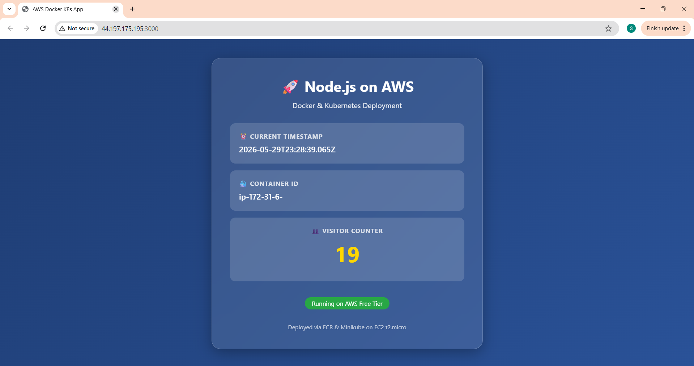

Figure 2. Node.js web application running in the browser, displaying live timestamp, container ID, and visitor counter via EC2 public IP on NodePort 3000.

Screenshot 02: Amazon ECR Repository
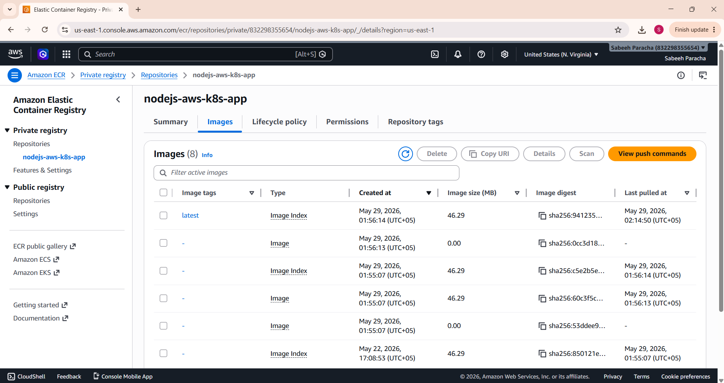
Figure 3. Amazon Elastic Container Registry (ECR) showing the nodejs-aws-k8s-app repository with the latest image tag pushed from the local Docker environment.

Screenshot 3: EC2 Instance Dashboard
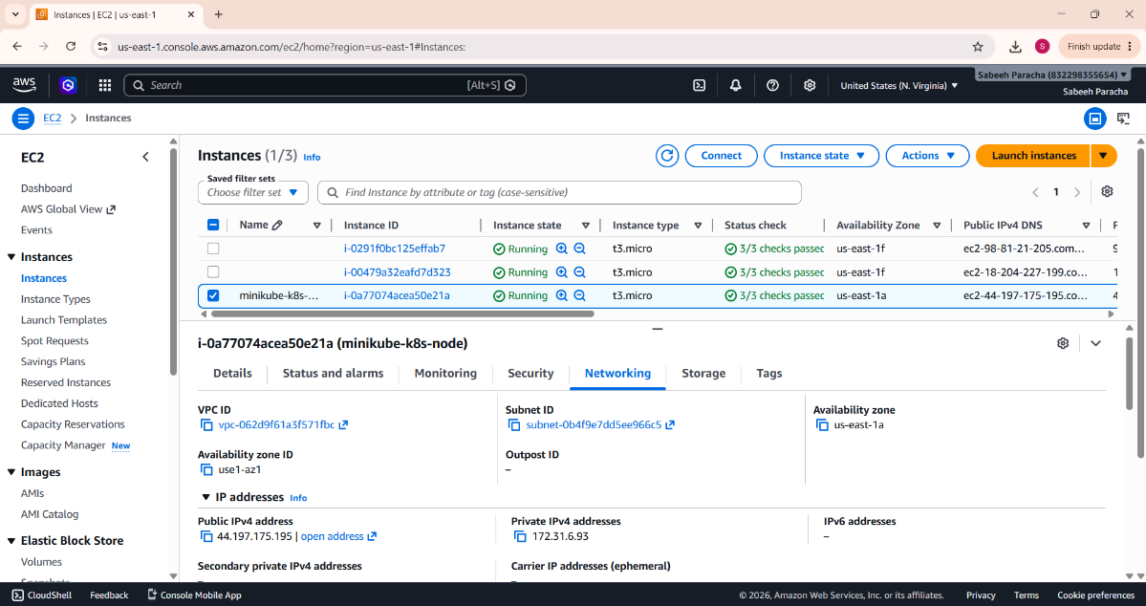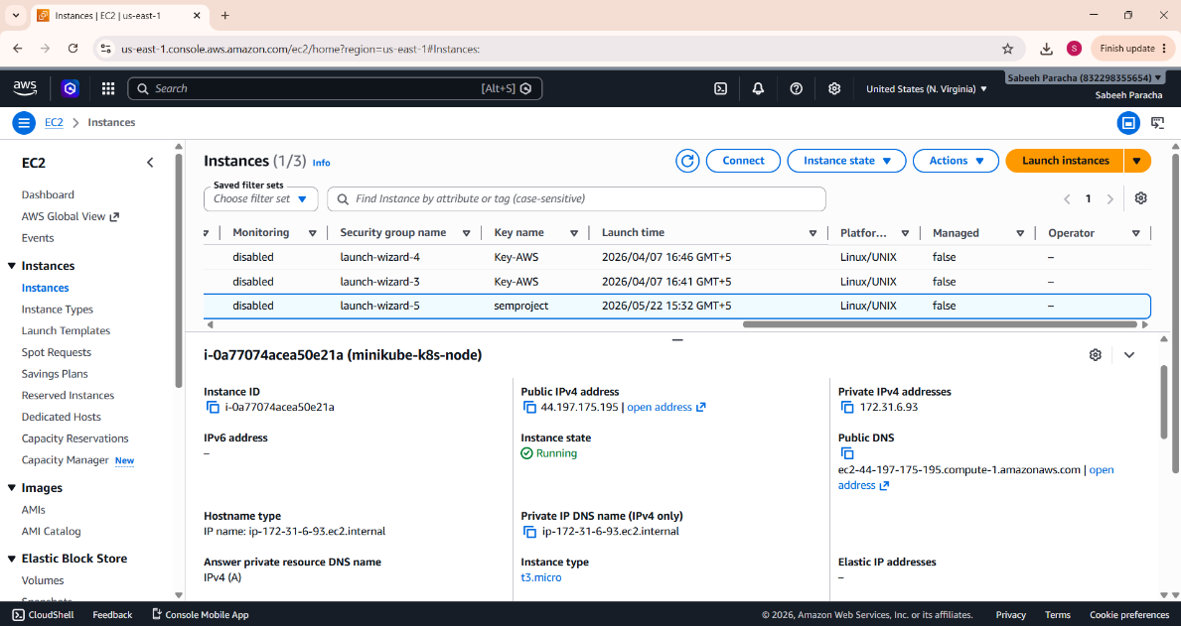
Figure 4. AWS EC2 Management Console displaying the running t2.micro instance (Free Tier eligible) with its public IPv4 address and running state.

Screenshot 4: Launching EC2 Server
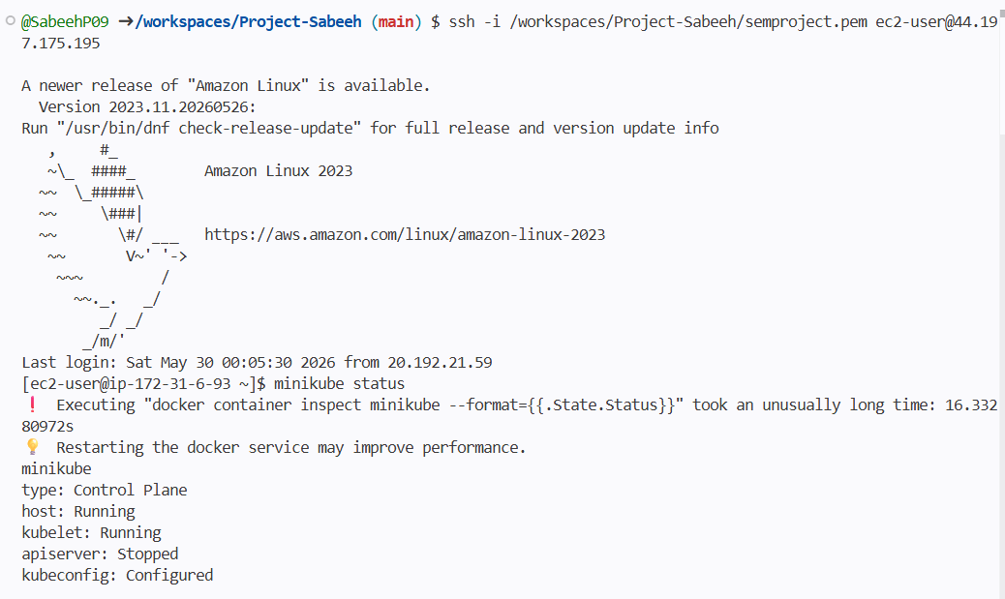

Figure 5. Launching EC2 Server on VS Code Terminal

Screenshot 5: Minikube Cluster Status

Figure 6. Minikube cluster status on the EC2 instance, confirming the single-node cluster is active and ready.

Screenshot 6: Docker Implementation
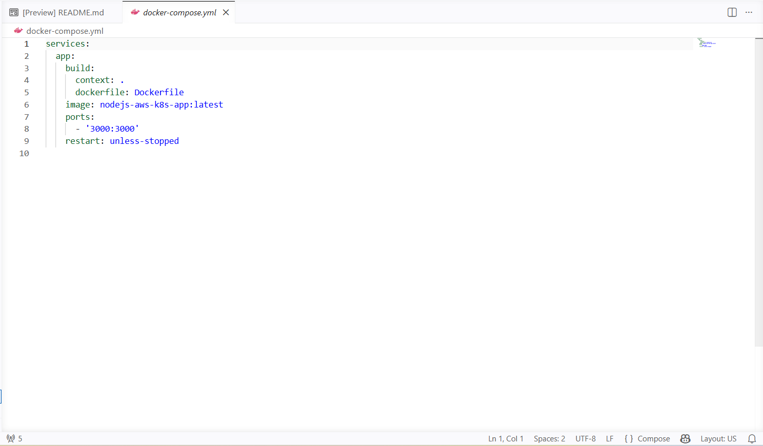
Figure 7. Implementation of Docker

Conclusion and Learnings
This project successfully demonstrated a complete DevOps pipeline by containerizing a Node.js application using Docker, storing it in Amazon ECR, and deploying it to a Minikube Kubernetes cluster on an EC2 t2.micro instance all at zero cost. Along the way, key lessons were gained across several areas: Docker's multi-stage builds proved effective at reducing image size and eliminating environment inconsistencies; ECR offered secure, IAM-integrated image storage; and Kubernetes, even on a single-node cluster, delivered powerful abstractions like Deployments, Services, and health probes for reliable orchestration. Cloud cost discipline was also reinforced through diligent resource cleanup, while security best practices including non-root containers, least-privilege IAM policies, and restricted security group rules highlighted the importance of building with production standards in mind from the start. Looking ahead, the project can be extended by integrating a GitHub Actions CI/CD pipeline, migrating to Amazon EKS for multi-node high availability, adding an ALB with Route 53 for production-grade traffic routing, and incorporating CloudWatch for centralized logging and monitoring.

